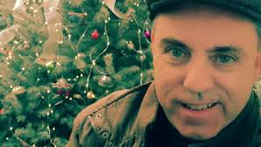
A Christmas Note to you, dear believers at Resurrection and Riderwood.
WHAT TIMES ARE THE MASSES? Christmas Eve Dec. 24th 9:45 am Arbor Ridge Room 3 pm Mass@Riderwood Chapel Christmas Day the 25th 9 am Riderwood Chapel
Resurrection Vigils
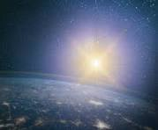
Christmas Eve Dec. 24th 4 pm Family Mass @ Resurrection
And an 8 p.m. Vigil Christmas Mass with choir (early carols)
Resurrection Christmas Day. 730am, 1030 am, 1230 pm.
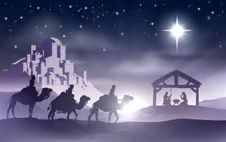
Hello from Fr. Barry. It was just back in 2020 when we had what scientists speculate was “the Christmas Star” over us at Christmas. It was the mysterious conjunction of two planets to resemble one bright star-looking object, that being Saturn and Jupiter. The science and math put it as once the case two millennia ago. It comes rarely over us, say astronomers, of what likely was the sign that led the magi to seek Christ and find Him in Bethlehem. The rare shining 'star' will appear again in 2080 a.d., this one that scientifically could explain the Light over Christ’ Birth. I’ve seen a few planetarium shows that show this Night Sky over Jesus long ago—such as at the Hayden in New York City. It still has a fascination with me, since my childhood days. Some songs celebrate a Christmas Star: 1/ Do You See What I See? A Star,A Star! Dancing in the night, with a tail as big as a kite. 2/ Star of the East, thou hope of the soul While round us here the dark billows roll Lead us from sin to glory afar Thou star of the East, thou sweet Bethlehem's star 3/ Noel, Noel, Noel, Noel. Born is the King of Israel. The Shepherds looked up and saw a star shining in the East beyond them far. And to the earth it gave great light and so it continued both day and night.
Anyway, each Christmas I usually look for a different perspective to the same Great Mystery of Christ and His Birth. This year it’ll be The Star. Of course, the heavenly light was just a pointer to the Light of The World. Jesus said it: “I am the Light of the World.” I like the old Douay-Rheims Catholic Bible version of John 8:12 that goes: Again therefore, Jesus spoke to them, saying: I am the light of the world: he that followeth me, walketh not in darkness, but shall have the light of life.
The Light of Christmas is a Person. Jesus Christ.
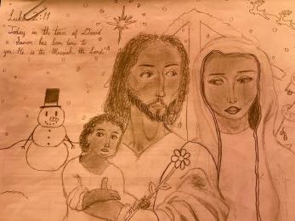
A Person. We won’t need to wait for that heavenly rarity again to 2080 star pairing. We can seek and find Christ Jesus, as He is come as the Word Incarnate, to “be with us always until the end of the ages” ^{Mt 28:16-20.} He IS Christmas Now and the Star of the Sacred Liturgy (as in each Mass) and He is the Saving One and Joy of our hearts presently. “Rise in splendor, your light is come” does proclaim the Word in the Epiphany Mass.
Now we are the wise ones to see Him, led by God in our own way to His Son, The Savior of the world. So hear Him call and note His sign(s) to you, and come be with us in The Church, His body ^{EPH 1:23} as the Christmas song beckons “O Come Let Us Adore Him, Christ the Lord!”
Whether we have a white Christmas or not, as the child’s poster above hopes for—The Joy of Jesus is always arriving at this Feast of His Nativity and Christmas Tide, and Epiphany and Epiphany Tide. Christ’ Mass is what goes on here in our parish home of Resurrection and of our partners in Riderwood. We are celebrants of Christmas—it’s our Catholic Holy Day. So let’s celebrate Christmas! Let our hearts cry out the song “Peace on earth, and Mercy mild, God and sinners reconciled! Joyful all ye nations rise!” (From Hark the Herald Angels)
The illustration of the Magi’s visit I put at the start of this message. Note how simply that Christmas image shows the Holy Family alone on the hill, and some more than curious visitors come to see The Babe. These God-sent Magi are Matthew’s Gospel ways of showing how one day Jesus would be the Light of the Gentiles, as well as Israel’s long-awaited Messiah. It’s an image our parish children know, as they drew it in some Keep Christ in Christmas posters. They are right below. Yours truly, Fr. John Barry
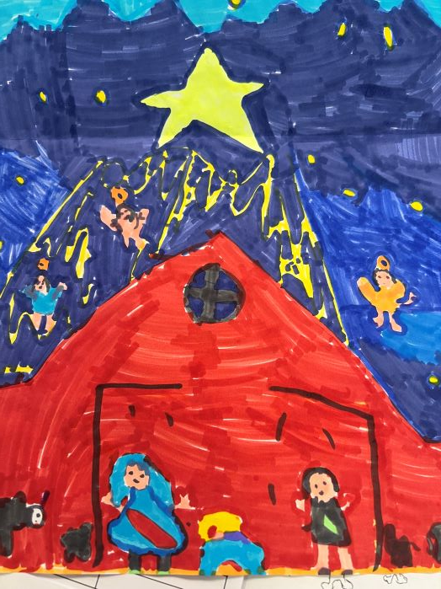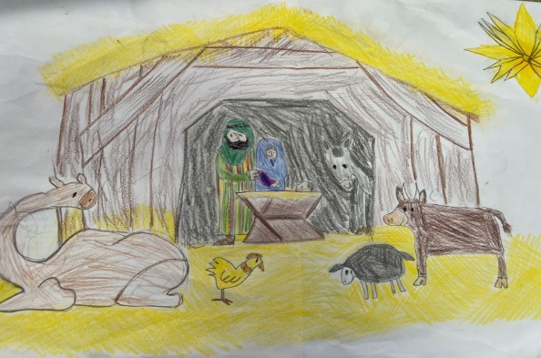
Christmas Season Masses >>> Christmas Octave continues with our usual weekday Resurrection and Riderwood Masses from Dec. 26 to Epiphany Sunday, and with Holy Family Masses in our Sunday Dec. 27th in-between and our New Year’s Masses to Mary. Epiphany is Sunday, Jan.4. Baptism of the Lord Sunday is Jan. 11th, ending Christmastime.
Note: YOUR CHRISTMAS DONATION IS GREATLY EXPECTED AND MOST APPRECIATED BY THE PARISH. THANKS. Fr. Barry.

